Topology Prelim, Spring 1999

Instructions
Attempt all problems. Problems 1-4, 6 and 7 are 10 points each. Problems 5 and 8 are 20 points each.

Problems

  - Let $S$ be a compact space and let $T$ be Hausdorff. Prove that any continuous bijection from $S$ to $T$ is a homeomorphism.
  - Show by examples that both assumptions in a) are necessary.
- Let $C$ be the “deleted comb space”
$$C=[0,1]×\{0\}∪\left(\underset{n}{⋃}\left\{\frac{1}{n}\right\}×[0,1]\right)∪\{(0,1)\}⊂R^{2}$$
- 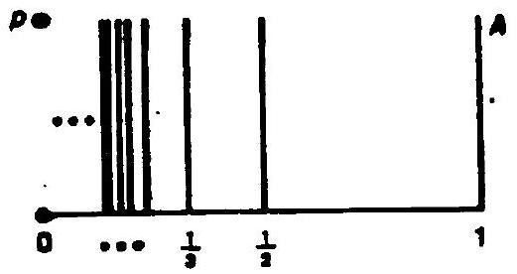
- Show that $C$ is connected but not locally connected and not path connected.
- Show by example that a quotient space of a Hausdorff space need not be Hausdorff.
- Classify all covering spaces of $RP^{2}×RP^{2}$. Show your reasoning.
- Let $X=S^{1}∨RP^{2}$, the one-point union of $S^{1}$ and $RP^{2}$.
  - Calculate the fundamental group $π_{1}(X)$ (show your work) and describe the universal covering space of $X$.
  - Calculate $H_{*}(X,Z)$ (show your work).
- Show that $Free(x_{1},…,x_{n})$, the free group on $n$ generators, is isomorphic to a subgroup of $Free(a,b)$, the free group on two generators.
- Let $Σ_{g}$, $g>0$, be a closed oriented surface of genus $g$. Let $π:Σ→Σ_{g}$ be a given connected $k$-fold cover of $Σ_{g}$. Given $g$ and $k$, determine what topological space $Σ$ is.

  - Suppose $f,g:S^{n}→S^{n}$ are maps with $f(x)≠g(x)$ for all $x$ in $S^{n}$. Show that $g$ is homotopic to $A∘f$ where $A$ is the antipodal map $A(x_{1},…,x_{n+1})=(-x_{1},…,-x_{n+1})$.
  - Use the statement of part a) to show that if $f:S^{2n}→S^{2n}$ is a continuous map, then there exists an $x$ in $S^{2n}$ with $f(x)=x$ or there exists a $y$ in $S^{2n}$ with $f(y)=-y$.

